ALUMNI EMAIL (12th MARCH 2026)
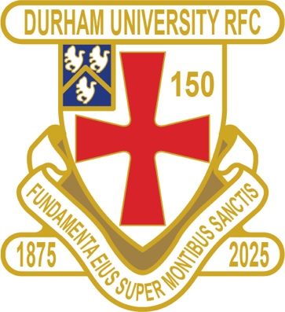
CLUB NEWS

RESULTS SATURDAY 7th MARCH 2026
PALATINATES XV GATESHEAD WON 28 – 26 RFU

RESULTS WEDNESDAY 11th MARCH 2026
1ST XV BATH LOST 7 – 17 BSR
2nd XV BIRMINGHAM 1 LOST 27 – 29 BUCS

FIXTURES SATURDAY 14th MARCH 2026
PALATINATES XV STOCKTON AWAY KO 2pm RFU

FIXTURES WEDNESDAY 18th MARCH 2026
1ST XV NO GAME
2nd XV NO GAME
3rd XV LEEDS BECKETT 2 HOME KO 330pm BUCS
4th XV NO GAME
5th XV LEEDS 3 HOME KO 1pm BUCS

FIXTURES SATURDAY 21st MARCH 2026
PALATINATES XV ACKLAM HOME KO 2pm RFU

- The 1st XV put up a valiant effort against Bath finishing 5th in BSR league and will no play at Nottingham in the quarter finals
- The 2nd XV finished 5th in BUCS Prem 2 North
- The 3rd XV finished 5th in North 1
- The 4th XV finished 4th in North 2
- The 5th XV finished 4th in North 3

You can also see the results on our official DURFC website, where you can also keep up to date with club news and follow the 1st XV live on twitter @durfc

* BUCS SUPER RUGBY FIXTURES 25/26 https://www.durfc1875.com/about-1-1

ALUMNI NEWS - #BleedPalatinate

INTERNATIONALS

Guy Pepper (2021 -24) wins his 12th Cap starting for England against France

Jamie Adamson ( 2018 -22) plays for NSW Waratahs A against Brumbies A

PREMIERSHIP CUP SEMI FINALS

Paul Brown Bampoe (2020 – 24) plays for Exeter Chiefs in the Premiership final
against Leicester Tigers

