ALUMNI EMAIL (30th MARCH 2026)
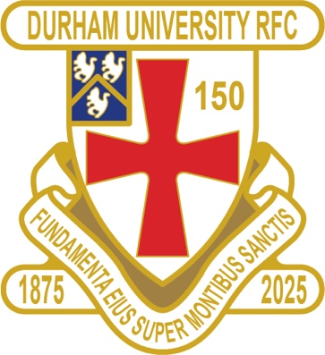
DURFC CLUB NEWS

FIXTURES SATURDAY 21st MARCH 2026
PALATINATES XV ACKLAM WON W/OVER RFU

RESULTS WEDNESDAY 25th MARCH 2026
1ST XV NOTTINGHAM WON 21-35 BSR ¼ FINALS

FIXTURES SATURDAY 28th MARCH 2026
PALATINATES XV DARLINGTON AWAY KO 2pm RFU

FIXTURES WEDNESDAY 8th APRIL 2026
1ST XV BATH AWAY KO 630pm BSR SEMI FINALS

REMAINING PATINATES FIXTURES
FIXTURES SATURDAY 11th APRIL 2026
PALATINATES XV PETERLEE & HORDEN HOME KO 2pm RFU

FIXTURES SATURDAY 18th APRIL 2026
PALATINATES XV HARTLEPOOL AWAY KO 2pm RFU

FIXTURES SATURDAY 25th APRIL 2026
PALATINATES XV RYTON HOME KO 2pm RFU

NB . The 1st XV will play either Bath AWAY in the semi-finals on the 8th April

CURRENT PLAYERS
Congratulations to Captain Marcus Rhodes who has signed for Coventry in the Championship next season

DURFC 7s PLANS
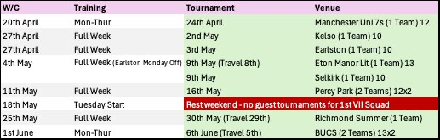
You can also see the results on our official DURFC website, where you can also keep up to date with club news and see what we are up to. www.durhamunirugby.com Follow the 1st XV live on twitter @durfc * BUCS SUPER RUGBY FIXTURES 25/26
https://www.durfc1875.com/about-1-1
ALUMNI NEWS - #BleedPalatinate

Premiership

Adam Brocklebank (2015-18) plays for Newcastle Red Bulls against Paul Brown Bampoe (2020-24) who plays for Exeter Chiefs

Fitz Harding (2018-21) and Max Pepper (2021-24) play for Bristol Bears against Harlequins

Osian Thomas ( current student) made his Premiership debut for Leicester Tigers against Bristol Bears

Super Rugby

Jamie Adamson (2018 -22) plays for NSW Waratahs against the Brumbies in Super Rugby

1875 SOCIETY
Thank you to all those alumni, supporters and parents for signing up to this vital fund-raising initiative. We still URGENTLY need your support for DURFC.
How to join - Please set up a standing order for £10 per month to the bank account below with your Surname/1875 as the reference:
ACCOUNT NAME: Durham University RFC Old Boys
ACCOUNT NUMBER: 00197878
SORT CODE: 30-99-80
PAYMENT: £10pm
REFERENCE: Your Surname followed by 1875
Please email: keaysie@hotmail.co.uk when you have set this up

PLEASE JOIN NOW - Thank you in advance for your support

SAVE THE DATE
1st MAY 2027 – MORE INFO SOON


