ALUMNI EMAIL (27th FEBRUARY 2026)
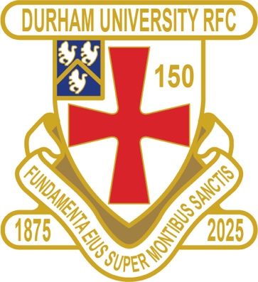
CLUB NEWS

RESULTS WEDNESDAY 18th FEBRUARY 2026
1ST XV LOUGHBOROUGH LOST 38 – 42 BSR
4th XV NEWCASTLE 4 LOST 36 – 39 BUCS

FIXTURES SATURDAY 28th FEBRUARY 2026
PALATINATES XV PONTELAND HOME KO 2pm RFU

FIXTURES WEDNESDAY 4th MARCH 2026
1ST XV SWANSEA AWAY KO 630pm BSR
2nd XV NEWCASTLE 2 AWAY KO 130pm BUCS
3rd XV LIVERPOOL 1 HOME KO 1pm BUCS
4th XV YORK 1 AWAY KO 3pm BUCS
5th XV SHEFFIELD 2 HOME KO 330pm BUCS

FIXTURES SATURDAY 7th MARCH 2026
PALATINATES XV GATESHEAD AWAY KO 2pm RFU

You can also see the results on our official DURFC website, where you can also keep up to date with club news and follow the 1st XV live on twitter @durfc

* BUCS SUPER RUGBY FIXTURES 25/26 - https://www.durfc1875.com/about-1-1

ALUMNI NEWS - #BleedPalatinate
PREMIERSHIP CUP
Toby Thame (Current student) plays for Northampton Saints against Saracens

Josh Basham (2018-21) is on the bench for Gloucester

Fitz Harding (2018-21) captains Bristol Bears against Sale Sharks

Adam Brocklebank (2015-18) plays for Newcastle Red Bulls against Harlequins

