ALUMNI EMAIL (20th APRIL 2026)
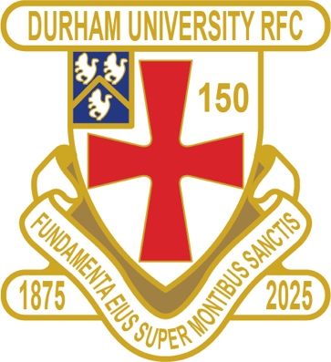
1875 SOCIETY DRAW 15 APRIL 2026
1st £ 100 85 JONATHAN POOLE
2nd £ 50 51 LEONARD GILL
3rd £ 25 70 RICHARD BASHAM

Draw dates- 20 May / 17 June / 15 July / 19 Aug
Thank you to all those alumni, supporters and parents for signing up to this vital fund-raising initiative.
We still URGENTLY need your support for DURFC.

The 1875 Club is supporting Ted Wood / Fergus King named Bursaries

If you benefited from the club — PLEASE this is your opportunity to give back.

Easy to join - Please set up a standing order for £10 per month to the bank account below with your Surname/1875 as the reference:
ACCOUNT NAME: Durham University RFC Old Boys
ACCOUNT NUMBER: 00197878
SORT CODE: 30-99-80
PAYMENT: £10pm
REFERENCE: Your Surname followed by 1875
Please email: keaysie@hotmail.co.uk when you have set this up

PLEASE JOIN NOW - Thank you in advance for your support
DURFC CLUB NEWS

RESULTS SATURDAY 11th APRIL 2026
PALATINATES XV PETERLEE & HORDEN WON 47 – 41 RFU

RESULTS SATURDAY 18th APRIL 2026
PALATINATES XV HARTLEPOOL LOST 24 – 31 RFU

FIXTURES SATURDAY 25th APRIL 2026
PALATINATES XV RYTON HOME KO 2pm RFU

You can also see the results on our official DURFC website, where you can also keep up to date with club news and see what we are up to www.durhamunirugby.com and https://www.durfc1875.com/about-1-1

ALUMNI NEWS - #BleedPalatinate
INTERNATIONAL
Claudia Moloney Macdonald (2014-17) is selected for the England Red Roses in the Womens Six Nations
Coreen Grant (2016-19) is in the Scotland squad in the Womens Six Nations

Premiership
Guy Pepper (2021-24) plays for Bath against Harlequins in the Premiership

Adam Brocklebank (2015-18) who plays for Newcastle Red Bulls against Leicester Tigers in the Premiership

Paul Brown Bampoe (2020-24) plays for Exeter Chiefs against Northampton in the Premiership

Fitz Harding (2018-21) plays for Bristol Bears against Gloucester in the Premiership

Super Rugby Jamie Adamson (2018 -22) plays for NSW Waratahs against the Moana Pasifika in Super Rugby

DURFC 150th SPONSOR



