ALUMNI EMAIL (5th MARCH 2026)
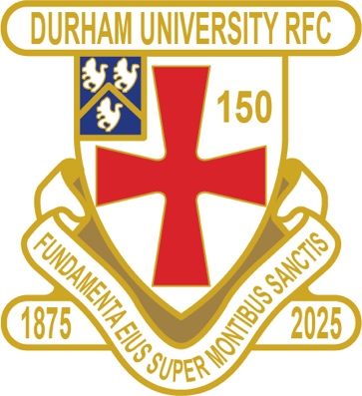
CLUB NEWS

FIXTURES SATURDAY 28th FEBRUARY 2026
PALATINATES XV PONTELAND WON 62 – 10 RFU

RESULTS WEDNESDAY 4th MARCH 2026
1ST XV SWANSEA WON 42 – 15 BSR
2nd XV NEWCASTLE 2 LOST 26 – 29 BUCS
3rd XV LIVERPOOL 1 LOST 19 – 80 BUCS
4th XV YORK 1 LOST 5 - 79 BUCS
5th XV SHEFFIELD 2 WON 34 – 21 BUCS

FIXTURES SATURDAY 7th MARCH 2026
PALATINATES XV GATESHEAD WON 28 – 26 RFU

FIXTURES WEDNESDAY 11th MARCH 2026
1ST XV BATH HOME KO 630pm BSR
2nd XV BIRMINGHAM 1 HOME KO 2pm BUCS
3rd XV NO GAME
4th XV NO GAME
5th XV NO GAME

FIXTURES SATURDAY 7th MARCH 2026
PALATINATES XV STOCKTON AWAY KO 2pm RFU

You can also see the results on our official DURFC website, where you can also keep up to date with club news and follow the 1st XV live on twitter @durfc

* BUCS SUPER RUGBY FIXTURES 25/26 - https://www.durfc1875.com/about-1-1

ALUMNI NEWS - #BleedPalatinate

INTERNATIONALS

Guy Pepper (2021 -24) wins his 11th Cap starting for England against Italy

PREMIERSHIP CUP SEMI FINALS

Toby Thame (Current student) played for Northampton Saints against Exeter Chiefs who play Paul Brown Bampoe (2020 – 24)

Arthur Green (2022-25) played for Bath against Leicester Tigers

