ALUMNI EMAIL (20th May 2026)
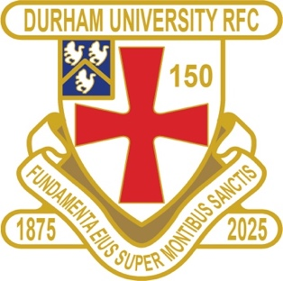
DURFC CLUB NEWS

1875 SOCIETY DRAW 20 MAY 2026
1st £ 100 37 MIKE MCKENZIE
2nd £ 50 27 PETER KEMBLE
3rd £ 25 1 STEVE COLWELL

Draw dates- 17 June / 15 July / 19 Aug
Thank you to all those alumni, supporters and parents for signing up to this vital fund-raising initiative.
We still URGENTLY need your support for DURFC.

The 1875 Club is supporting Ted Wood / Fergus King named Bursaries

If you benefited from the club — PLEASE this is your opportunity to give back.

Easy to join - Please set up a standing order for £10 per month to the bank account below with your Surname/1875 as the reference:
ACCOUNT NAME: Durham University RFC Old Boys
ACCOUNT NUMBER: 00197878 SORT CODE: 30-99-80
PAYMENT: £10pm REFERENCE: Your Surname followed by 1875
Please email: keaysie@hotmail.co.uk when you have set this up
===========================================================================ENGLAND STUDENTS Congratulations to Louis Inman Ethan Hulme, Finn Baker Marcus Rhodes who played for England Students in the winning team against French Students
ALUMNI NEWS - #BleedPalatinate
INTERNATIONAL Claudia Moloney Macdonald ( 2014-17) played for the title winning England Red Roses team in the Womens Six Nations
INTERNATIONAL Coreen Grant (2016-19) played for Scotland squad in the Womens Six Nations
INTERNATIONAL Jamie Adamson (2018 -22) plays for NSW Waratahs in Super Rugby

Current DURFC Alumni playing in the Premiership
Guy Pepper (2021-24) plays for Bath
Fitz Harding (2018-21) plays for and Captains Bristol Bears
Paul Brown Bampoe (2020-24) plays for Exeter Chiefs
Adam Brocklebank (2015-18) plays for Newcastle Red Bulls
Toby Thame (2023-26) plays for Northampton Saints
Finn Baker (2023-26) plays for Newcastle Red Bulls
Max Pepper (2021-24) play for Bristol Bears


