ALUMNI EMAIL (7th October 2025)
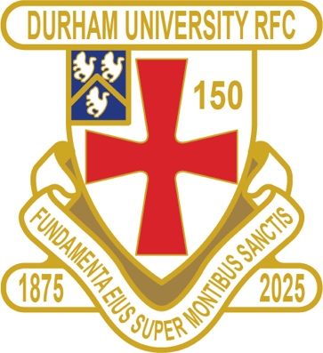
DURFC CLUB NEWS

RESULTS WEDNESDAY 24th SEPTEMBER 2025
1ST XV LEEDS BECKETT AWAY LOST 24-27 BSR
RESULTS WEDNESDAY 1st OCTOBER 2025
1ST XV NOTTINGHAM HOME LOST 26-29 BSR
2nd XV UNI of DONCASTER HOME WON 24-21 BUCS
RESULTS SATURDAY 20th SEPTEMBER 2025
PALATINATES XV GATESHEAD HOME WON 36-12 RFU CUP
RESULTS SATURDAY 4th OCTOBER 2025
PALATINATES XV BISHOP AUCKLAND AWAY WON 41-17 RFU

FIXTURES WEDNESDAY 8th OCTOBER 2025
1ST XV CARDIFF AWAY KO 6pm BSR
2nd XV GLASGOW 1 AWAY KO 1pm BUCS
3rd XV NO FIXTURE
4th XV NO FIXTURE
5th XV NO FIXTURE
FIXTURES SATURDAY 11th OCTOBER 2025
PALATINATES XV NOVOCASTRIANS AWAY KO 2pm RFU
You can also see the results on our official DURFC website, where you can also keep up to date with club news and see what we are up to. www.durhamunirugby.com
You can follow the 1st XV live on twitter @durfc

* BUCS SUPER RUGBY FIXTURES 25/26
https://www.durfc1875.com/about-1-1

ALUMNI NEWS - #BleedPalatinate – SUMMER NEWS !!!

Claudia Moloney Macdonald (2015-17) wins the Women’s Rugby World Cup as part of the England Roses

In the Premiership,

Guy Pepper (2021-24) played in Baths win against Harlequins and this week against Sale

Adam Brocklebank (2015-18) plays for Newcastle Red Bulls in their defeat against Saracens and this week in their defeat to Exeter

Fitz Harding (2018-21) captains for the 50th time in his 100th match and scores for Bristol Bears against Leicester

Paul Brown (2020-24) starts for Exeter and scores in their draw with Northampton and their win this week against Newcastle

Max Pepper (2021-24) plays for Bristol Bears in their defeat against Saracens

1875 CLUB
Thank you to all those alumni, supporters and parents for signing up to this vital fund-raising initiative. We still URGENTLY need your support for DURFC-please see here for details on joining the DURFC Alumni 1875 Club for £10 per month or £ 120 per annum,which includes free entry to the monthly draw.
PLEASE JOIN NOW - Thank you in advance for your support
NEXT DRAW WEDNESDAY 15th OCTOBER 2025

PLANNING A REUNION / GOLF WEEKEND
PLEASE CONTACT THE RAMSIDE HOTEL 0191 386 5282

SAVE THE DATE – FRIDAY 12th DECEMBER 2025 FRIDAY NIGHT LIGHTS KO 745pm
ALUMNI LONDON EVENT at Rosslyn Park
DURFC vs CARDIFF
BUCS SUPER RUGBY

