ALUMNI EMAIL (17th October 2025)
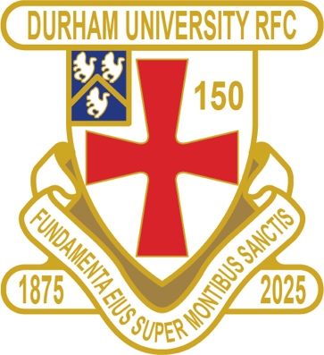
1875 SOCIETY
1875 CLUB DRAW 15 OCTOBER 2025
1st £ 100 32 GEOFF BROMILEY
2nd £ 50 22 WILLIAM DASHWOOD
3rd £ 25 55 LAWRENCE TOYE

Draw dates-19 Nov/12 Dec/14 Jan/18 Feb/18 Mar/15 Apr/20 May
Thank you to all those alumni, supporters and parents for signing up to this vital fund-raising initiative. We still URGENTLY need your support for DURFC – please see here for details on joining the DURFC 1875 Society for £10 per month, which includes free entry to the monthly draw.
PLEASE JOIN NOW – IT WILL TAKE YOU LESS THAN A MINUTE
Thank you in advance for your support
DURFC CLUB NEWS

RESULTS SATURDAY 11th OCTOBER 2025
PALATINATES XV NOVOCASTRIANS AWAY LOST 32 -31 RFU

RESULTS WEDNESDAY 15th OCTOBER 2025
1ST XV CARDIFF MET HOME WON 17-14 BSR
2nd XV NO GAME
3rd XV NEWCASTLE 3 HOME LOST 39-36 BUCS
4th XV NEWCASTLE 4 AWAY LOST 24-14 BUCS
5th XV LEEDS 3 AWAY KO 2pm BUCS

FIXTURES WEDNESDAY 22nd OCTOBER 2025
1ST XV EXETER AWAY KO 745pm BSR
2nd XV ST ANDREWS 1 HOME KO 3pm BUCS
3rd XV LEEDS BECKETT 2 HOME KO 2pm BUCS
4th XV BISHOP BURTON 1 HOME KO 2pm BUCS
5th XV NORTHUMBRIA 4 HOME KO 2pm BUCS
FIXTURES SATURDAY 18th OCTOBER 2025
PALATINATES XV STOCKTON HOME KO 2pm RFU

You can also see the results on our official DURFC website, where you can also keep up to date with club news and see what we are up to. www.durhamunirugby.com
You can follow the 1st XV live on twitter @durfc

* BUCS SUPER RUGBY FIXTURES 25/26
https://www.durfc1875.com/about-1-1

ALUMNI NEWS - #BleedPalatinate – SUMMER NEWS !!!

In the Premiership – Alumni clashes

Guy Pepper (2021-24) played in Baths win against Gloucester who featured Josh Basham (2018-21) for his debut

Adam Brocklebank (2015-18) plays for Newcastle Red Bulls in their defeat against Sale Sharks

Fitz Harding (2018-21) and Max Pepper (2021-24) play for Bristol Bears against Exeter Chiefs who have Paul Brown (2020-24) on the wing


PLANNING A REUNION / GOLF WEEKEND
PLEASE CONTACT THE RAMSIDE HOTEL 0191 386 5282

TICKETS AVAILABLE – FRIDAY 12th DECEMBER 2025 FRIDAY NIGHT LIGHTS KO 745pm
ALUMNI LONDON EVENT at Rosslyn Park
DURFC vs CARDIFF
BUCS SUPER RUGBY

