ALUMNI EMAIL (23rd JANUARY 2026)
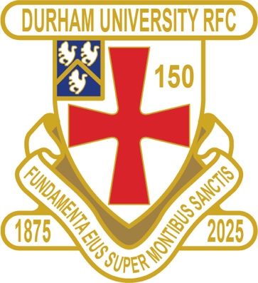
CLUB NEWS
GET THE BRUSH OUT – WELL DONE BOYS IT’S A CLEAN SWEEP

RESULTS SATURDAY 17th JANUARY 2026
PALATINATES XV BISHOP AUCKLAND WON 45 - 32 RFU

RESULTS WEDNESDAY 21st JANUARY 2026
1ST XV EXETER WON 34 - 14 BSR
2nd XV NEWCASTLE 2 WON 42 - 31 BUCS
3rd XV LEEDS 2 WON 78 - 19 BUCS
4th XV NORTHUMBRIA 2 WON 38 - 17 BUCS

FIXTURES SATURDAY 24th JANUARY 2026
PALATINATES XV NOVOCASTRIANS HOME KO 2pm RFU

FIXTURES WEDNESDAY 28th JANUARY 2026
1ST XV LEEDS BECKETT HOME KO 6pm BSR
2nd XV BIRMINGHAM 1 AWAY KO 6pm BUCS
3rd XV LIVERPOOL 1 AWAY KO 2pm BUCS
4th XV YORK 1 HOME KO 2pm BUCS
5th XV SHEFFIELD 2 AWAY KO 2pm BUCS

You can also see the results on our official DURFC website, where you can also keep up to date with club news and follow the 1st XV live on twitter @durfc
* BUCS SUPER RUGBY FIXTURES 25/26
https://www.durfc1875.com/about-1-1

ALUMNI NEWS - #BleedPalatinate

IN THE PREMIERSHIP

Finn Baker (Current Student) and Adam Brocklebank (2015-18) played for Newcastle Red Bulls against Saracens

Paul Brown Bampoe (2020 - 24 plays for Exeter Chiefs against Bristol Bears who have Captain Fitz Harding (2018-21) in their team

Guy Pepper (2021 -24) and Arthur Green (2022-25) play for Bath against Gloucester

PRIDE OF PLACE AND A HUGE WELL DONE TO GUY PEPPER (2021 -24) SELECTED FOR THE ENGLAND 6 NATIONS SQUAD

1875 SOCIETY

Draw dates-18 Feb/18 Mar/15 Apr/20 May
Thank you to all those alumni, supporters and parents for signing up to this vital fund-raising initiative. We still URGENTLY need your support for DURFC.
How to join - Please set up a standing order for £10 per month to the bank account below with your Surname/1875 as the reference:
ACCOUNT NAME: Durham University RFC Old Boys REFERENCE: Your Surname followed by 1875
ACCOUNT NUMBER: 00197878 SORT CODE: 30-99-80 PAYMENT: £10pm
Please email: keaysie@hotmail.co.uk when you have set this up
PLEASE JOIN NOW - Thank you in advance for your support

