ALUMNI EMAIL (19th MAY 2025)
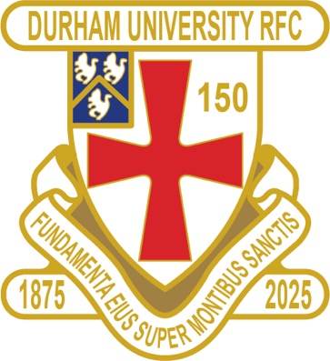
1875 CLUB
1875 CLUB DRAW 14 MAY 2025
1st £ 100 19 SARAH WILLIAMSON
2nd £ 50 8 DANIEL KEATING
3rd £ 25 24 ADAM CLARKE

Future draw & newsletter dates for 2025:
18 June- 16 July – 20 Aug – 17 Sept

Thank you to all those alumni, supporters and parents for signing up to this vital fund-raising initiative.
We still URGENTLY need your support for DURFC – please see here for details on joining the DURFC Alumni 1875 Club for £10 per month, which includes free entry to the monthly draw. PLEASE JOIN NOW - Thank you in advance for your support

DURFC CLUB NEWS
The 150th Match between the Barbarians and Durham University RFC ended in a win for the Barbarians 64-33

Below are some photos.

Men’s Match:
https://adobe.ly/4lYuTmw

Women’s Match: https://lightroom.adobe.com/shares/0b5df4589e784a13ab471f467b39453c

The 3rd XV narrowly misses out on promotion losing play offs with Glasgow 1st and Nottingham 2
ALUMNI NEWS THIS WEEK #BleedPalatinate

IN THE PREM…..
EXETER CHIEFS – Paul Brown (2020-24) played against Harlequins

BRISTOL BEARS were led by Fitz Harding ( 2018-2021) against Sale Sharks

NEWCASTLE FALCONS -Max Pepper (2021-24), Ben Stevenson (2016-19) and Adam Brocklebank (2015-18) all played against Gloucester

DOWN UNDER ….
NEW SOUTH WALES WARATAHS – Jamie Adamson (2018-22) played for New South Wales Waratahs against the Crusaders in Super Rugby

