ALUMNI EMAIL (16th JANUARY 2026)
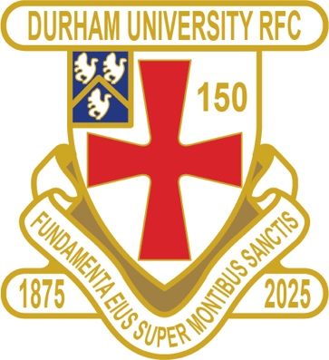
HAPPY NEW YEAR TO ALL OUR READERS
1875 SOCIETY
1875 SOCIETY DRAW 14th JANUARY 2026
1st £ 100 2 John Delaney
2nd £ 50 69 Ashley Hepponstall
3rd £ 25 34 Josh Beaumont

Draw dates-18 Feb/18 Mar/15 Apr/20 May
Thank you to all those alumni, supporters and parents for signing up to this vital fund-raising initiative. We still URGENTLY need your support for DURFC.
How to join - Please set up a standing order for £10 per month to the bank account below with your Surname/1875 as the reference:
ACCOUNT NAME: Durham University RFC Old Boys REFERENCE: Your Surname followed by 1875
ACCOUNT NUMBER: 00197878 SORT CODE: 30-99-80 PAYMENT: £10pm
Please email: keaysie@hotmail.co.uk when you have set this up
PLEASE JOIN NOW - Thank you in advance for your support
CLUB NEWS
FIXTURES SATURDAY 17th JANUARY 2026
PALATINATES XV BISHOP AUCKLAND HOME KO 2pm RFU

FIXTURES WEDNESDAY 21st JANUARY 2026
1ST XV EXETER HOME KO 2pm BSR
2nd XV NEWCASTLE 2 AWAY KO 4pm BUCS
3rd XV LEEDS 2 HOME KO 2pm BUCS
4th XV NORTHUMBRIA 2 HOME KO 2pm BUCS
5th XV NO GAME

FIXTURES SATURDAY 24th JANUARY 2026
PALATINATES XV NOVOCASTRIANS HOME KO 2pm RFU

RESULTS FRIDAY 12th DECEMBER 2025
1st XV CARDIFF WON 24 – 20 BSR

RESULTS SATURDAY 13th DECEMBER 2025
PALATINATES XV PETERLEE & HORDEN LOST 31 - 24 RFU

RESULTS SATURDAY 3rd JANUARY 2026
PALATINATES XV HARTLEPOOL WON 45 – 12 RFU

You can also see the results on our official DURFC website, where you can also keep up to date with club news You can follow the 1st XV live on twitter @durfc
* BUCS SUPER RUGBY FIXTURES 25/26
https://www.durfc1875.com/about-1-1

ALUMNI NEWS - #BleedPalatinate

Over the festive season a number of our Alumni played Premiership and European rugby

Toby Thame (Current student) played for Northampton Saints

Finn Baker (Current Student) and Adam Brocklebank (2015-18) played for Newcastle Red Bulls

Fitz Harding (2018-21) and Max Pepper (2021-24) played for Bristol Bears

Guy Pepper (2021 -24) and Arthur Green (2022-25) played for Bath

Josh Basham (2018-21) played for Gloucester

Paul Brown Bampoe (2020 - 24 played for Exeter Chiefs

