ALUMNI EMAIL (31st October 2025)
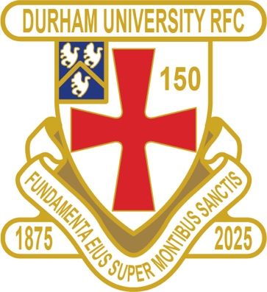
DURFC CLUB NEWS

RESULTS WEDNESDAY 29th OCTOBER 2025
1ST XV SWANSEA HOME WON 43-24 BSR
2nd XV NO GAME
3rd XV NO GAME
4th XV NO GAME
5th XV NEWCASTLE 5 HOME LOST 26-33 BUCS

RESULTS SATURDAY 25th OCTOBER 2025
PALATINATES XV RYTON AWAY WON 34-22 RFU CUP

FIXTURES WEDNESDAY 5th NOVEMBER 2025
1ST XV NO GAME BSR
2nd XV LOUGHBOROUGH 3 AWAY KO 4pm BUCS
3rd XV SHEFFIELD 1 HOME KO 1pm BUCS
4th XV NORTHUMBRIA 2 AWAY KO 1230pm BUCS
5th XV LEEDS BECKETT 4 HOME KO 2pm BUCS

FIXTURES SATURDAY 8th NOVEMBER 2025
PALATINATES XV PONTELAND AWAY KO 2pm RFU

You can also see the results on our official DURFC website, where you can also keep up to date with club news and see what we are up to. www.durhamunirugby.com
You can follow the 1st XV live on twitter @durfc

* BUCS SUPER RUGBY FIXTURES 25/26
https://www.durfc1875.com/about-1-1

ALUMNI NEWS - #BleedPalatinate

International Alumni
Guy Pepper (Durham 2021-24) starts for England against Australia at Twickenham

Fitz Harding (2018-21) starts for the Barbarians against the All Blacks at the GTech stadium

In the Premiership

Arthur Green (2022-25) played for Bath against Leicester Tigers

Adam Brocklebank (2015-18) plays for Newcastle Red Bulls in their defeat against Harlequins

Josh Basham (2018-21) played for Gloucester against Exeter Chiefs

1875 SOCIETY
Thank you to all those alumni, supporters and parents for signing up to this vital fund-raising initiative. We still URGENTLY need your support for DURFC.
How to join - Please set up a standing order for £10 per month to the bank account below with your Surname/1875 as the reference:
ACCOUNT NAME: Durham University RFC Old Boys
ACCOUNT NUMBER: 00197878
SORT CODE: 30-99-80
PAYMENT: £10pm
REFERENCE: Your Surname followed by 1875
Please email: keaysie@hotmail.co.uk when you have set this up

PLEASE JOIN NOW - Thank you in advance for your support
NEXT DRAW WEDNESDAY 19th NOVEMBER 2025


PLANNING A REUNION / GOLF WEEKEND
PLEASE CONTACT THE RAMSIDE HOTEL 0191 386 5282

THE TED WOOD CHALLENGE MATCH
TICKETS AVAILABLE – FRIDAY 12th DECEMBER 2025 FRIDAY NIGHT LIGHTS KO 745pm
ALUMNI LONDON EVENT at Rosslyn Park
DURFC vs CARDIFF BUCS SUPER RUGBY

Early Bird tickets run until 10th November.
https://fixr.co/event/durham-university-rfc-v-cardiff-university-rfc-tickets-486980241

