ALUMNI EMAIL (24th October 2025)
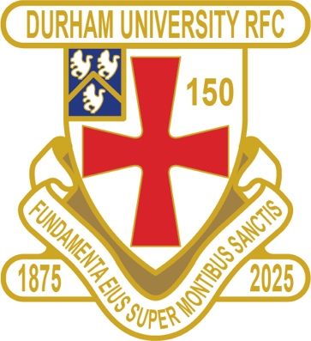
DURFC CLUB NEWS

RESULTS SATURDAY 18th OCTOBER 2025
PALATINATES XV STOCKTON HOME WON 42-38 RFU

RESULTS WEDNESDAY 22nd OCTOBER 2025
1ST XV EXETER AWAY LOST 7 - 45 BSR
2nd XV ST ANDREWS 1 HOME LOST 19-22 BUCS
3rd XV LEEDS BECKETT 2 HOME LOST 14-40 BUCS
4th XV BISHOP BURTON 1 HOME W/O BUCS
5th XV NORTHUMBRIA 4 HOME WON 55-14 BUCS

FIXTURES SATURDAY 25th OCTOBER 2025
PALATINATES XV RYTON AWAY KO 2pm RFU CUP

RESULTS WEDNESDAY 29th OCTOBER 2025
1ST XV SWANSEA HOME KO 630 pm BSR
2nd XV NO GAME
3rd XV NO GAME
4th XV NO GAME
5th XV NEWCASTLE 5 HOME KO 1pm BUCS

You can also see the results on our official DURFC website, where you can also keep up to date with club news and see what we are up to. www.durhamunirugby.com
You can follow the 1st XV live on twitter @durfc

* BUCS SUPER RUGBY FIXTURES 25/26
https://www.durfc1875.com/about-1-1

ALUMNI NEWS - #BleedPalatinate

In the Premiership

Arthur Green (2022-25) played for Bath against Leicester Tigers

Adam Brocklebank (2015-18) plays for Newcastle Red Bulls in their defeat against Northampton

Fitz Harding (2018-21) and Max Pepper (2021-24) play for Bristol Bears against Gloucester who had Josh Basham (2018-21) in their ranks

There are 3 former BSR players in the England squad Guy Pepper (Durham 2021-24), Max Ojomoh (Bath)

1875 SOCIETY
Thank you to all those alumni, supporters and parents for signing up to this vital fund-raising initiative. We still URGENTLY need your support for DURFC.
How to join - Please set up a standing order for £10 per month to the bank account below with your Surname/1875 as the reference:
ACCOUNT NAME: Durham University RFC Old Boys
ACCOUNT NUMBER: 00197878
SORT CODE: 30-99-80
PAYMENT: £10pm
REFERENCE: Your Surname followed by 1875
Please email: keaysie@hotmail.co.uk when you have set this up

PLEASE JOIN NOW - Thank you in advance for your support
NEXT DRAW WEDNESDAY 19th NOVEMBER 2025


PLANNING A REUNION / GOLF WEEKEND
PLEASE CONTACT THE RAMSIDE HOTEL 0191 386 5282

TICKETS AVAILABLE – FRIDAY 12th DECEMBER 2025 FRIDAY NIGHT LIGHTS KO 745pm
ALUMNI LONDON EVENT at Rosslyn Park
DURFC vs CARDIFF BUCS SUPER RUGBY

Early Bird tickets run until 1st November.
https://fixr.co/event/durham-university-rfc-v-cardiff-university-rfc-tickets-486980241

