ALUMNI EMAIL (15th DECEMBER 2025)
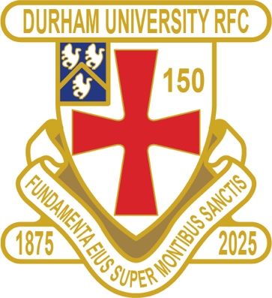
MERRY CHRISTMAS & A HAPPY HEALTHY NEW YEAR
TO ALL OUR READERS ⛄🎅
(NEXT NEWSLETTER 16th JANUARY 2026)

DURFC CLUB NEWS

1875 SOCIETY

1875 SOCIETY DRAW 10th DECEMBER 2025
1st £ 100 37 MIKE MCKENZIE
2nd £ 50 19 ALEX HAMBLY
3rd £ 25 48 MICHAEL COLATO

Draw dates-14 Jan/18 Feb/18 Mar/15 Apr/20 May
Thank you to all those alumni, supporters and parents for signing up to this vital fund-raising initiative. We still URGENTLY need your support for DURFC.
How to join - Please set up a standing order for £10 per month to the bank account below with your Surname/1875 as the reference:
ACCOUNT NAME: Durham University RFC Old Boys REFERENCE: Your Surname followed by 1875
ACCOUNT NUMBER: 00197878 SORT CODE: 30-99-80 PAYMENT: £10pm
Please email: keaysie@hotmail.co.uk when you have set this up
PLEASE JOIN NOW - Thank you in advance for your support
NEXT DRAW WEDNESDAY 14th JANUARY 2026
=======================================================================================
RESULTS FRIDAY 12th DECEMBER 2025
1ST XV CARDIFF WON 24 - 21 BSR

RESULTS SATURDAY 13th DECEMBER 2025
PALATINATES XV PETERLEE & HORDEN LOST 31 - 24 RFU

You can also see the results on our official DURFC website, where you can also keep up to date with club news www.durhamunirugby.com You can follow the 1st XV live on twitter @durfc

* BUCS SUPER RUGBY FIXTURES 25/26
https://www.durfc1875.com/about-1-1

ALUMNI NEWS - #BleedPalatinate

EUROPE

Toby Thame (Current student) played for Northampton Saints against Pretoria Bulls in the Champions Cup

Finn Baker (Current Student) and Adam Brocklebank (2015-18) played for Newcastle Red Bulls against Johannesburg Lions in the Challenge Cup

Fitz Harding ( 2018-21) played for Bristol Bears against Pau in the Champions Cup

Arthur Green (2022-25) played for Bath against Munster in the Champions Cup

Josh Basham played for Gloucester against Munster in the Champions Cup

