ALUMNI EMAIL (7th NOVEMBER 2025)
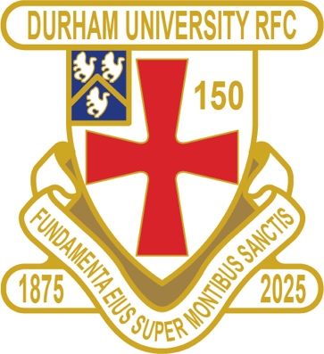
DURFC CLUB NEWS

RESULTS SATURDAY 25th OCTOBER 2025
PALATINATES XV RYTON AWAY WON 34-22 RFU CUP

RESULTS WEDNESDAY 29th OCTOBER 2025
1ST XV NO GAME BSR
2nd XV LOUGHBOROUGH 3 AWAY LOST 43-44 BUCS
3rd XV SHEFFIELD 1 HOME LOST 26-31 BUCS
4th XV NORTHUMBRIA 2 AWAY LOST 8-74 BUCS
5th XV LEEDS BECKETT 4 HOME LOST 12-26 BUCS

FIXTURES SATURDAY 8th NOVEMBER 2025
PALATINATES XV PONTELAND AWAY KO 2pm RFU

FIXTURES WEDNESDAY 12th NOVEMBER 2025
1ST XV BATH AWAY KO 630pm BSR
2nd XV NEWCASTLE 1 HOME KO 4pm BUCS CUP
3rd XV UC DONCASTER 1 AWAY KO 230pm BUCS CUP
4th XV LEEDS 1 HOME KO 1pm BUCS CUP
5th XV KEELE 1 AWAY KO 6pm BUCS CUP

You can also see the results on our official DURFC website, where you can also keep up to date with club news and see what we are up to. www.durhamunirugby.com
You can follow the 1st XV live on twitter @durfc

* BUCS SUPER RUGBY FIXTURES 25/26
https://www.durfc1875.com/about-1-1

ALUMNI NEWS - #BleedPalatinate

International Alumni

Guy Pepper (Durham 2021-24) starts for England for his 5th Cap against Fiji at Twickenham

Fitz Harding (2018-21) benches for England “A” for his 1st Cap against the All Blacks at Bath

1875 SOCIETY
Thank you to all those alumni, supporters and parents for signing up to this vital fund-raising initiative. We still URGENTLY need your support for DURFC.
How to join - Please set up a standing order for £10 per month to the bank account below with your Surname/1875 as the reference:
ACCOUNT NAME: Durham University RFC Old Boys
ACCOUNT NUMBER: 00197878
SORT CODE: 30-99-80
PAYMENT: £10pm
REFERENCE: Your Surname followed by 1875
Please email: keaysie@hotmail.co.uk when you have set this up

PLEASE JOIN NOW - Thank you in advance for your support
NEXT DRAW WEDNESDAY 19th NOVEMBER 2025

PLANNING A REUNION / GOLF WEEKEND
PLEASE CONTACT THE RAMSIDE HOTEL 0191 386 5282

THE TED WOOD CHALLENGE MATCH
TICKETS AVAILABLE – FRIDAY 12th DECEMBER 2025 FRIDAY NIGHT LIGHTS KO 745pm
ALUMNI LONDON EVENT at Rosslyn Park
DURFC vs CARDIFF BUCS SUPER RUGBY

Early Bird tickets run until 10th November.
https://fixr.co/event/durham-university-rfc-v-cardiff-university-rfc-tickets-486980241

