ALUMNI EMAIL (31st MARCH 2025)

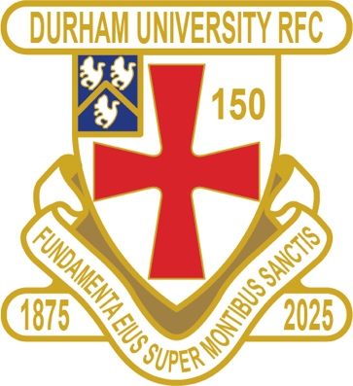

RESULTS WEDNESDAY 26th MARCH 2025

1ST XV EXETER LOST 21 -55 BSR ¼ FINALS

RESULTS SATURDAY 29th MARCH 2025

PALATINATES DMP ELIZABETHIANS WALK OVER RFU

CLUB NEWS
Sadly the 1st XV lost against old foes Exeter in the BSR Nationals Championship Quarter Finals.

You can also see the results on our official DURFC website, whilst keeping you up to date with club news-www.durhamunirugby.com.
Please follow the 1stXV live on twitter @durfc

ALUMNI NEWS
IN THE PREMIERSHIP….
Guy Pepper (2021-2024) played for Bath in their win against Harlequins

Bristol Bears Fitz Harding (2018-2021) was Captain in their loss to Gloucester

Exeter Chiefs winger Paul Brown (2020 – 2024) played in their win against Newcastle Falcons who featured Adam Brocklebank (2015-2018) and Ben Stevenson (2016-19)

DOWN UNDER …
Jamie Adamson (2018-22) played for New South Wales Waratahs against the Hurricanes in Super Rugby

150th MERCHANDISE

https://www.moette.co.uk/Durham-University-RFC-150-Anniversary

👀 👀
DURFC CLUB & ALUMNI 150th CELEBRATIONS 2025

DURFC vs THE BARBARIANS
Saturday 3rd May 2025 KO 3pm
At Durham City Rugby Club Hollow Drift

TICKET LINK
https://fixr.co/event/durfc-v-the-barbarians-tickets-231750238

www.durfc1875.com

